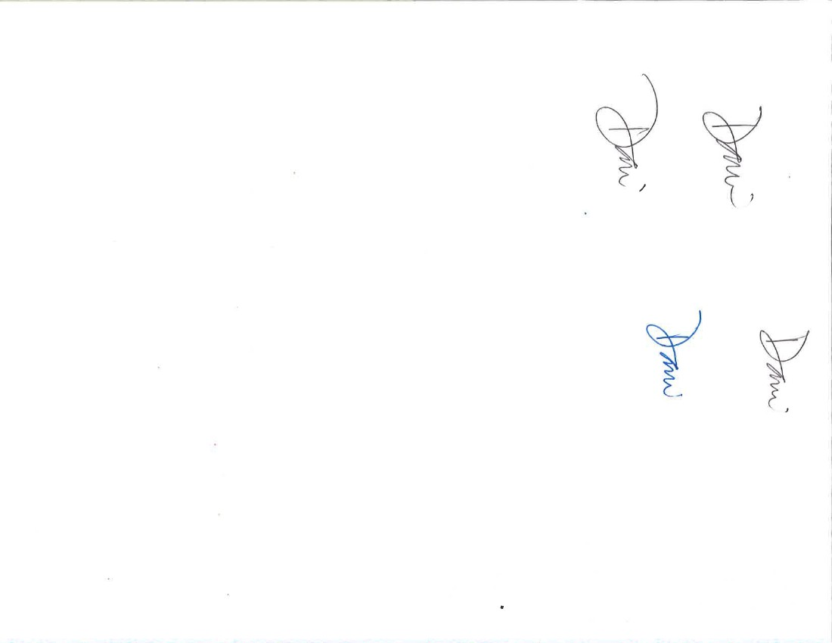

Letter from the Pastor

**Dear Northminster Family,**

First, I want to thank you all for the hospitality I have received from this congregation. You have shown me love and as a young minister it is a blessing to be a part of such a wonderful congregation. My time here has been formative and I will be able to recall my experience at Northminster throughout my ministry career. In ministry, I continually remind myself to be grounded and remember why I do ministry.

One of the most compelling stories for my own personal faith is in Matthew 18 & 19. It is when Jesus interacts with children. Chapter 18 starts with the disciples asking Jesus, “Who is the greatest in the kingdom of heaven?” Instead of indulging these grown adults in their immature banter Jesuscalled a child over to him and said, “Truly I tell you, unless you change and become like children, you will never enter the kingdom of heaven. Whoever becomes humble like this child is the greatest in the kingdom of heaven. Whoever welcomes one such child in my name welcomes me.”

The *adults* in this story feel as if they know what is best (for goodness sake they were asking which one of them is the greatest). They forgot what following Jesus was about. Following Jesus is not about who is greatest.

Jesus says in Matt. 20, “…the last will be first and the first will be last.” The disciples were focused on things that did not matter.

That is why Jesus showed them the child and told them that they must be like this child. The child doesn’t speak in the passage and the child’s silence teaches us about humility. The child didn’t care about who was the greatest. The child only cared about being near Jesus. In Jesus’ Kingdom, greatness is not reached by any standards of our own, but by the devotion to Jesus.

In Chapter 19:13, the children are being brought to Jesus in order that he might lay his hands on them and pray. But the disciples scolded those who were bringing them. Then Jesus said, “Let the little children come to me, and do not stop them; for it is to such as these that the kingdom of heaven belongs.”

This second story, the disciples rebuke those who were bringing children to Jesus. They thought that Jesus should not be bothered by the trivial things like children. These children do not have authority and Jesus has bigger fish to fry. Although, Jesus tells them the opposite. He reminds them that these children are the one which will fill his Kingdom.

Northminster Presbyterian Church • 7706 25th Ave NW • Seattle, WA 98117 • 206-783-3402 • [www.northminsterpres.org](http://www.northminsterpres.org) • “Look for us on Facebook!”

**Proclaiming God’s Grace, Creating Community, Serving**

**our Neighbors**

**Pastor**

Rev. Dani Forbess

**Organist**

Eric Johnston

**Christian Ed Director**

Ally Pexa

**Choir Diretor**

Kevin Gospel

**Office Manager**

Stacy Kern

**Pastoral Intern**

Davidson Sutherland

**Clerk of Session**

Ann Wightman

**Board of Elders**

Myla Belston

Lars Carlson

Tom Haff

Dana Hammer

Scott Monrad

Becky Rufin

Jan Olson

Katherine Voyles

Rachel Van Noord

Trisha Wirta

**Board of Deacons**

Sandy Coyer

Lisa Horowitz

Nancy Ingle

Jennifer Jensen

Julia Miller

Robert Porter

Sheila Striegl

Dawn Thornhill

David Voyles

Ben Woldseth

**News Editor**

Ally Pexa

Northminster News

**Volume LVIII, No. 8 August 2017 2017**

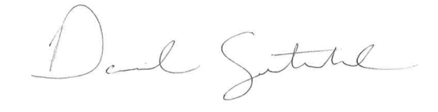

A two week class on

**The Wisdom of our Songs**

This is an opportunity to learn more about the importance of hymns and music in worship. Taught by Dani Forbess. Coffee and light refreshments will be offered. Coffee at 9am August 6th and 13th. Class will start at 9:15am.

Hi Northminster Family!

Though the choir is officially off for the summer season, we had our first Summer Pick-up choir gathering in July. It was great to see both familiar and new faces joining the group. Thanks to all who came out!

In case you missed it, we will be having one more of these gatherings on Sunday, August 20th. We meet in the choir room at 9:30am to learn a brand new song that we’ll sing during that morning’s church service. There is not prior experience required! Just come ready to learn and have fun praising God!

Finally, the choir will be beginning rehearsals for the fall season on Thursday,, September 7th at 7:30pm. If you are interested feel free to come give us a no-pressure look-see. We’d love to incorporate other music lovers into our ministry!

If you have any questions or suggestions, feel free to contact our choir director, Dr. Kevin Gospel at [kevin.gospel@northminsterpres.org](mailto:kevin.gospel@northminsterpres.org)

Kevin Gospel

Yet again, Jesus shows us that the priority of the Kingdom of God is not in who the is greatest or our own agendas. What fills the Kingdom of God is our devotion to God and to one another. Remember the Greatest commandments. Love the Lord your God and love your neighbor as yourself.

Everything else doesn’t matter. The Kingdom of God is not about *preferences*. It is about *Love.*

These are two short stories, but two stories that I think are very profound. According to the Gospels, Jesus is often surrounded by children and children find themselves drawn to Jesus.

During this time let us all look at ourselves and wonder what it means to come to Jesus as a child; for they are doing something right.

With Love,

David

# 

**Summer Fun**

We’ve had lots of summer fun so far and the summer’s only half over. We kicked off the summer with a BBQ and a Baptism! Everyone enjoyed the Carlson’s beautiful beach front and hospitality. Ally and David have had a game day and a zoo trip with the kids. Georgia and David boogied at the Locks while the rest of us watched amazed! David organized a couple men’s nights and many enjoyed our last two Pub Nights! Georgia and Ann Kurtz threw a wonderful sloppy joe potluck at their beautiful home and garden. Some of us took on a challenging book, Brueggemann’s *God, Neighbor, Empire*. Olaf, the Forbess dog/pony, even had a little vacay while his family was out of town.

There’s more to come! Next up is a **tea at Lisa Lady’s house—8/2 at 2pm**. A group will attend a **Mariner game on 8/11 at 7pm**. The **Hammer BBQ, originally scheduled for 8/17 is rescheduled to 9/7 at 6 pm**. Our second **concert in the Locks is Sat, 8/19 at 2 pm** where we’ll see the Microsoft Jump ‘n Jive Orchestra. **Signa Treat and Pat Breckenridge will throw a BBQ on 8/23 at Signa’s house at 6 pm**.

I hope you’re able to join in the NPC fun this summer!

Stacy Kern

**Youth and Children’s Happenings**

Check out what is coming up this month!

**8/20 All Ages Worship**—There will be no Sunday school on this day, so children are invited to worship with their families. The balcony will have space and activities for children to play with during the worship service.

**8/20 Pool Day**- NPC youth will be having a pool day! RSVP to Ally by Friday, August 18, if your child is planning to attend. Children under the age of 7 must be accompanied by an adult

**8/28-9/1 Creative Camp!!!** Join us for a week of music, stories, and art! If you are interested in volunteering, contact Ally at ally.pexa@northminsterpres.org

**A note from Ann Wightman**

I received a wonderful phone call this noon from the head nurse in the UW hospital radiation. He was calling since today I was ten days out of treatment and he needed to know how I was doing and if I had any questions. The big news was that this is about the time that all the little annoyances after treatment ends start to dry up. This gave me a great boost for the immediate future.

I also told him that I had great help at home and good friends praying for me he assured me that this would definitely make things move a little faster.

I was doubly impressed since this was the first time in two years since this started that someone from the medical world cared enough to check on me without my instigating the contact. I can’t tell you how good this made me feel.

And thanks to all the people who’ve called and sent cards, especially our wonderful deacons. I’m planning to send out some individual thank you’s if I ever get organized!

Love,

Ann

A



Concert in the Locks

Join us on Saturday, August 19th, for our

second concert in the locks. Bring a lunch or

snack and come listen to the Microsoft Jumpin’

Jive Orchestra at 2 pm.

**Climbing Mount Olympus**

After two other attempts in the last five years, I finally managed to summit Mount Olympus earlier this summer. Ballard climbing friends joined Trisha and me for the five-day adventure. Just to reach basecamp, is a two-day backpack up the Hoh River Valley, including climbing a two hundred-foot-long wire and wood rung ladder dangling against the steep side of a ravine. On summit day Trisha hiked to the spectacular Blue Glacier, while I climbed with our guide and my buddy. It took 14.5 hours including the last few hundred feet of vertical pitch, but at the end of the day we stood on the summit and below us were the uncountable peaks and icy glaciers of Olympic National Park. I was elated. It was a difficult journey, one that tested me sorely. No epiphany to report, but I do understand why God chose a mountain top for the meeting of earth and heaven during the transfiguration. It’s said that when you climb you see, but when you descend and can no longer see, at least you have still known.

Bret Wirta

**Congrats to our 2017 Confirmands for taking this step in their faith journeys!**

(Pictured from left to right: Lydia Rice, Abbie Knapp, Karina Hammer, Delaney Hammer, Erika Carlson, Ellie Knapp, Scout Brown, and Andy Voyles)

# 

# 

**LECTIONARY FOR SUNDAYS IN AUGUST**

|  |  |  |  |
| --- | --- | --- | --- |
| **August 6** | **August 13** | **August 20** | **August 27** |
| Matthew 14:13-21 | Matthew 12:1-14 | Matthew 12:33-42 | Matthew 15:10-28 |
| Exodus 20:18-21 | Exodus 24:9-18 | Exodus 32:1-6 | Exodus 32:7-14 |

Northminster Presbyterian Church

*A village church in the city*

7706 25th Avenue NW

Seattle, WA 98117

206-783-3402

***RETURN SERVICE REQUESTED***

Please Notify us with corrections if needed, or if you wish

to stop receiving the Northminster News



August Schedule

8/2- 2 pm Tea in Lisa Lady’s Garden

8/6- 9 am Adult Education: Wisdom of

our Songs

8/11- NPC goes to the Mariners!

8/13- 9 am Adult Education: Wisdom of our Songs

10:30 am Elise’s Baptism!

8/16- 7:30 pm Trivia Night @ The Dane

8/19- 2 pm Concert in the Locks

8/20- 9:30 am Pick-Up Choir and 2 pm Pool Day

8/23- 6 pm Signa Treat and Pat Breckenridge’s BBQ @ Signa’s house